At the zero lower bound for interest rates the combination of flexible prices and rational expectations is no longer sufficient to ensure that full employment output will be achieved. Discuss that claim. Evaluate the likely effectiveness of policy measures that central banks could use to stimulate demand when interest rates are at the zero lower bound.

In this essay, I argue that flexible prices (FP) and rational expectations (RE) are not sufficient at the zero lower bound (ZLB) to ensure that full employment output will be achieved. Then I discuss forward guidance and the two channels, inflation expectations and interest rate expectations, that it works through. Then, I argue that this can be time inconsistent, and that this can potentially be solved through price path (PP) targeting. Then, I explain how a PP target has further advantages because it reduces the probability of hitting the ZLB and having demand deficiency, and I will explain some drawbacks of it. Finally, I discuss how quantitative easing (QE) works and how it can be useful when the interest rates are at the ZLB. Very good intro

Zero lower bound

During the Great Recession after 2008, many economies significantly contracted. This led to a big negative output gap, driving inflation down. To counteract this, central banks (CBs) lowered interest rates to boost the economy and increase inflation back to target. However, it is impossible for CBs to cut nominal rates to far below zero. Firstly because CBs cannot tolerate to lend at negative interest rates for a long time as they would make a loss. And secondly because commercial banks are better off holding on to cash and earning a 0% return (or maybe slightly negative as there are costs involved in holding cash) than depositing it with the CB and earning a negative return. Nice empirical example

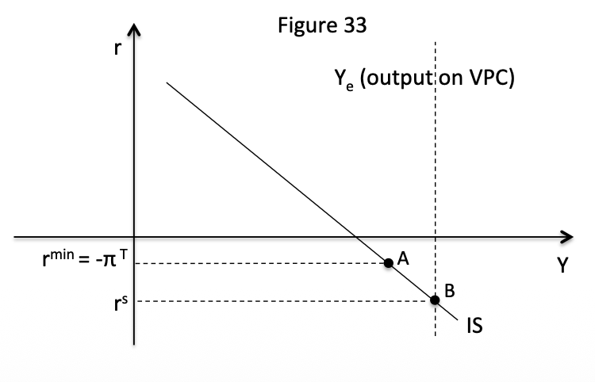
When nominal interest rates are at zero, real interest rates are at negative inflation, which we assume starts at target. Using the figure, if there is a negative demand shock and the CB would like to lower real interest rates to r^{s} to achieve point B which is at equilibrium output. However, the ZLB on real interest rates is at r^{min} which is equal to negative target inflation. So the central bank will only achieve point A. However, at A there is still a negative output gap so inflation and expected inflation will fall, and as a result r^{min} increases which causes an even larger output gap which then spirals into further deflation. ZLB actually emerge mostly because of Japan.

Rational expectations and flexible prices

When the economy is not at the ZLB, perfectly rational inflation expectations and perfectly flexible prices, the CB does not actually have to do anything. If the inflation expectations are rational, then expecting anything else than the inflation target will be irrational. This is because the central bank would increase or decrease interest rates to get inflation closer to the target and so inflation would not be equal to the inflation expectations of the private sector. Because the private sector knows this, their inflation expectation will be target inflation. If there are also FP, any deviation in inflation, for instance in a cost-push shock, will immediately be fixed as the private sector immediately updates their prices to reflect their inflation expectation which would be the inflation target. As a result, RE and FP are sufficient to ensure that full employment output will be achieved.

However, as Krugman (1998) argues, RE and FP at the ZLB only worsen the deflationary spiral. RE worsens it because it causes inflation to fall further. When there is a negative output gap because only point A can be achieved, inflation will fall. A falling inflation will cause expected inflation to fall. Under adaptive expectations it will fall slowly, but under RE it will fall much quicker as rational agents will know that the economy is going into a deflationary spiral. Since the real interest rate is dependent on expected inflation, it will increase by a greater amount than under adaptive expectations, worsening the deflationary spiral. FP make this even worse as prices will reflect inflation expectations quicker, making inflation fall faster. Therefore, RE and FP make the deflationary faster and are no longer sufficient to ensure that full employment output is achieved. This is what Krugman calls the “curse of flexibility”. Very good reference to Krugman

Forward guidance

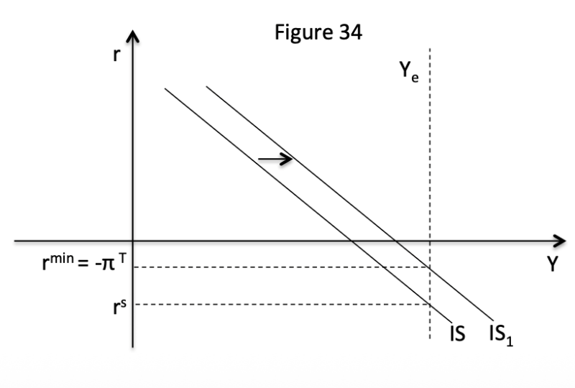
When short-term interest rates are at the ZLB, the CB can adopt other policy measures to stimulate the economy and get inflation and output back to target. Firstly, the CB can signal that it will keep policy rates at the ZLB for longer than was previously expected. This works through two channels: long-term policy rates and inflation expectations. Long-term policy rates are affected because signals regarding future policy feed into current long-term rates. The interest paid on a 10-year bond is the average of the expected short-term interest rates plus a risk premium. If expected interest rates fall because the CB signals that it will keep policy rates at the ZLB, long-term interest rates go down, even if it does not change current interest rates. Lower long rates matter for private consumption and investment because banks often source funding for mortgages and corporate loans in money markets in which the opportunity cost of money is the long-term government bond yield, so lower long rates mean cheaper financing for banks and ultimately for firms and households. This shifts the IS-curve right, making it possible to achieve their desired real interest rate.

It also works through inflation expectations. The CB can signal that it will keep interest rates at the ZLB for longer than it would want to to achieve their target inflation. They signal that they will overshoot their inflation in the future and so the CB “commits to irresponsibility” as they pledge to keep policy rates at ZLB not only until the economy
equilibrates but until inflation exceeds the official target. This raises the expected inflation rate if there are some RE, pushing the ZLB down, making it so that the CB can achieve their desired real interest rate.

Price-path targets

However, this policy is time inconsistent. When the CB achieves the target inflation, there is an incentive to not fulfil its promise of keeping interest rates low. Since the private sector knows this, it is difficult for the CB to credibly commit to forward guidance. This is why some economists argue for a PP-target. Here the CB does not try to achieve a certain target inflation, but instead targets an average of a certain amount of inflation. This would mean that the CB has to ensure that any deviations from the price path that occur have to be reversed. As a result, when the inflation is below target for a while, to achieve the PP-target, it will have to be above target for a while. Therefore, setting a PP-target makes forward guidance no longer time inconsistent as the CB no longer has an incentive to not fulfil its promise, instead it will fulfil its promise of forward guidance.

There are also other benefits of a PP-target. As Gaspar et al. (2007) have argued, a PP-target reduces the probability of hitting the ZLB. A common criticism of CBs is that when adverse developments take place there is a delay in monetary stimulus being provided. This delay means that adverse demand multipliers set in. For instance, firms that would have stayed in business had rates and debt service costs been lowered end up bankrupt and lay off workers who in turn cut consumption and reduce income elsewhere. As a result, further rate cuts are required at the ZLB looms nearer. On the other hand, with a PP-target, CBs can respond quicker as they do not have to be afraid that they make cause inflation to increase to much after a negative demand shock, as they are aiming for a higher inflation rate anyway.

Finally, another policy measure that CBs can use at the ZLB is QE. With QE, CBs buy up assets from commercial banks to give them additional liquidity. They can then pass on this additional liquidity to the private sector, effectively decreasing interest rates. This can also be a way of committing to forward guidance, as actions speak louder than words and CBs can this way commit to keeping lower interest rates. However, some have criticized this by arguing that CBs can simply sell the assets that they bought again, removing the liquidity from the system.

In conclusion, at the zero lower bound the self-correcting properties normally associated with flexible prices and rational expectations break down, as both can intensify deflationary pressures and widen the output gap rather than restore full employment. When nominal rates cannot fall further, declining inflation and expectations raise real interest rates, deepening the downturn and creating the risk of a deflationary spiral. In this environment, unconventional tools become essential. Forward guidance can lower long-term rates and raise inflation expectations, but it suffers from credibility and time-inconsistency problems. A price-path target can strengthen commitment and reduce the likelihood of returning to the ZLB, though it may pose communication and credibility challenges. Quantitative easing can further ease financial conditions and reinforce policy commitments, yet its impact depends on transmission channels and expectations about future policy.

This is a really good essay, it definitely deserves a distinction! Well done!

Bibliography
Gaspar, Smets and Vespin (2007) Is time Ripe for Price Path Level Stability? European
Central Bank working paper 818.
Krugman, P. (1998). It’s Baaack: Japan’s Slump and the Return of the Liquidity Trap.
Brooking Papers on Economic Activity, pages 137-205

